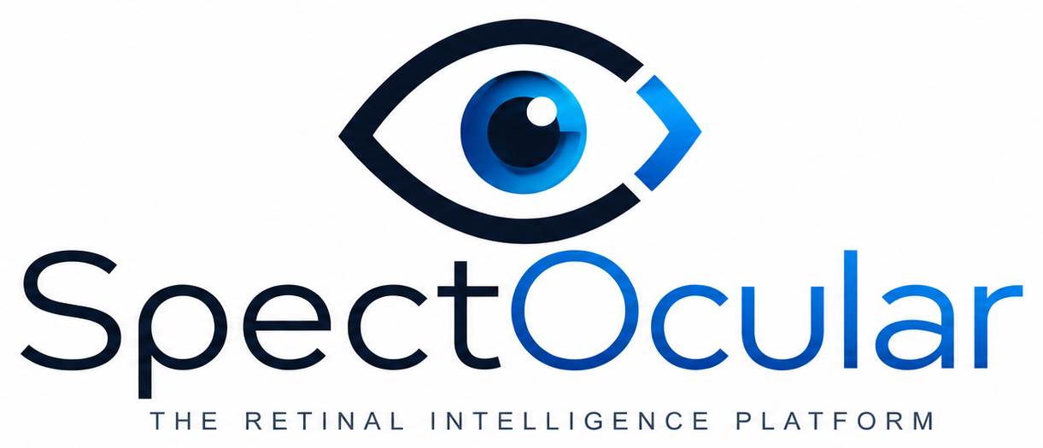 | INFORMATION FOR PATIENTS  RESEARCH PARTICIPATION

About the SpectOcular Research Study
A simple guide to what this research is, and what taking part means for you
Your eye care team is inviting you to take part in a research study. Taking part is completely your choice. This page answers the questions patients ask most often. Your team is happy to walk through any of it with you.
◉ What is the purpose of this research?
The retina — the light-sensing tissue at the back of your eye — is the one place in the body where doctors can look directly at tiny blood vessels and nerve tissue without any surgery. Researchers are studying whether patterns in routine retinal images, analyzed with artificial intelligence, can help predict and monitor the health of vital organs such as the heart, brain and nervous system, and kidneys.

◉ Will this benefit me personally?
No — there is no direct medical benefit to you from taking part. The study is observational: it does not diagnose you, does not change your care, and its results are not shared with you or your doctor to guide treatment.
What your participation does do is help build knowledge that may allow doctors to better predict and monitor systemic health in future patients — potentially catching risk earlier, for many people down the road.

◉ What will I have to do? Are there extra tests?
Nothing beyond your normal visit. The study uses only the retinal images already taken as part of your routine eye care — color fundus photos and OCT scans. No additional imaging, appointments, medications, or procedures are performed just for research.

◉ Will my data be kept private and anonymous?
Your privacy is protected carefully. Your images and health information are labeled with a randomly assigned study code, not your name. The list connecting your identity to that code is kept separately, with access limited to authorized study personnel, and information is stored in secure, access-controlled systems.
Note: The privacy and consent details of this study are subject to review and approval by an Institutional Review Board (IRB), an independent committee that protects the rights and welfare of research participants. Final privacy protections will follow the IRB-approved consent and HIPAA authorization documents you will be asked to sign.

◉ Is taking part voluntary?
Yes. Participation is entirely voluntary. You may decline, or withdraw at any time, and your decision will not affect your care or your relationship with your eye care team in any way.

◉ Can I speak with someone from the SpectOcular research team before I decide?
Yes. Before you sign, you can request the opportunity to speak by phone or video with licensed SpectOcular research personnel to ask any questions about the study, or call 214-233-6170 directly. This is available whether or not you choose to take part, and asking questions does not commit you to participating.

Questions? Please ask your eye care team or the study coordinator before you decide. You will receive the full informed consent and HIPAA authorization documents to review and sign if you choose to take part.

SpectOcular — The Retinal Intelligence Platform  Patient information sheet. This document is for general information and does not replace the IRB-approved informed consent. | Version 1.0 (draft)  Pending IRB approval · Effective ________

