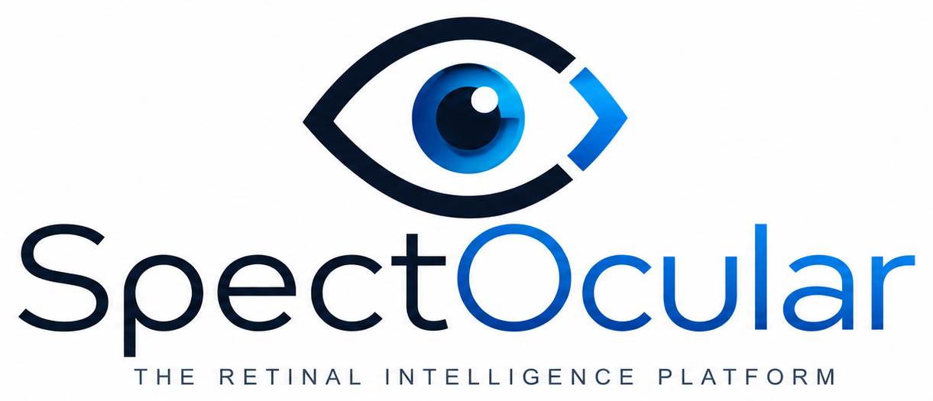 | STAFF REFERENCE  IMAGING MODALITIES

Retinal Imaging on the Topcon Maestro 3D
Color fundus · OCT · OCT-A — what each captures and why the study collects it
The Topcon Maestro 3D acquires all three modalities below in a single, automated, non-contact session. Use this sheet to understand what each scan shows and to answer patient questions. Reminder: only imaging acquired as part of routine clinical care is included — nothing is captured solely for research.

Color Fundus Photography | CFP
WHAT IT CAPTURES
A wide, true-color photograph of the surface of the retina — the optic nerve head, macula, and the retinal blood vessels — in a single non-mydriatic (typically no-dilation) shot.
WHY THE STUDY COLLECTS IT
The retinal vessels are the only blood vessels in the body that can be photographed directly and non-invasively. Their caliber, branching, and appearance carry signals linked to cardiovascular and systemic vascular health, making the color photo a foundational input for the AI analysis.

Optical Coherence Tomography | OCT · STRUCTURAL
WHAT IT CAPTURES
A high-resolution cross-sectional (“optical biopsy”) scan that images the individual layers of the retina in depth, including the nerve fiber and ganglion cell layers and the macula, at micron-level detail.
WHY THE STUDY COLLECTS IT
Retinal layer thickness reflects neural tissue — a direct extension of the central nervous system. Structural OCT provides quantitative measures relevant to brain aging, neurodegeneration, and stroke risk, complementing what the surface photo cannot show.

OCT Angiography | OCT-A · IF AVAILABLE
WHAT IT CAPTURES
A dye-free map of blood flow through the fine capillary networks of the retina and choroid, imaging the microvasculature layer by layer without any injection.
WHY THE STUDY COLLECTS IT
OCT-A visualizes the smallest vessels — the microcirculation — where early damage from diabetes, kidney disease, and vascular disease often first appears. When clinically acquired, it adds a rich microvascular signal to the analysis. Collected only when clinically indicated and available on the device.

At export
Include color fundus, structural OCT, and OCT-A (when available) in the raw export — DICOM when supported, otherwise the most complete vendor-supported raw format. Do not alter files inside the exported package, and never copy or synchronize the live Topcon database.

⚠ Clinical care comes first
These modalities are part of routine care. Research use does not change acquisition, and AI outputs are investigational — they do not guide care and are not communicated to patients.

SpectOcular — The Retinal Intelligence Platform  Staff reference. Device: Topcon Maestro 3D. For imaging technique, follow the manufacturer’s instructions and your clinical protocol. | Version 1.0  Effective ________  Prepared by Sai H. Chavala, MD

